**Hong Kong Institute of Vocational Education (Tsing Yi)**

**Department of Information Technology**

**Higher Diploma in Software Engineering (IT114105)**

**Human Computer Interaction & GUI Programming (ITP4506)**

**Coursework (Semester 4 2016/2017)**

|  |  |  |  |
| --- | --- | --- | --- |
| Student ID | Name | Contribution | Signature |
| 150258241 | Tang Chi Fai | 50% | fai |
| 150137271 | Lee Wai Shing | 50% | **shing** |

Contents

1 User Analysis 3

1.1 User Characteristics 3

a. Learning Style 3

b. Tool preference 3

c. Physical differences 3

d. Cultural differences 3

e. Knowledge of job 4

f. Application familiarity 4

1.2 Techniques for observing and listening to users 4

1.3 Environment Analysis 4

1.4 Recruiting Users 4

1.5 Task Analysis (HTA) 5

2 Web Design Concepts 6

# User Analysis

## User Characteristics

### Learning Style

* IVE students also like do anything by themselves, they always do-then-read. When they learning something new, they would like to try first without reading instruction. After problem occur at trying, they will find another for help.
* IVE students do anything as fast as they can, they always ignore some points of the actions. We need to make sure them confirm the action they doing.

### Tool preference

* They always use laptop and tablet when learning at the lecture room. Also they use desktop with mouse and keyboard doing the workshop. They play game and surfing the net on the smartphone so that they easy to know about the icon or animation of functional button.

### Physical differences

* Although IVE students are teenager, they need more graphic design to attract them. They can read normal fonts and colors so that we do not need do any special setting.

### Cultural differences

* They all are in higher diploma level, they can easy to find out the solution of the problem they face in. They study and work with English as main language, but lot of them still talk in Chinese.

### Knowledge of job

* Use computer frequently, they always work with different computer application. All their work need using computer as basic.

### Application familiarity

* A computer expert, they can solve the simple problems and can perform a complex series of tasks.

## Techniques for observing and listening to users

We had taking online survey to obtain our results for choosing our products. We had get the result for identify our products.

## Environment Analysis

Many users may use at home or school. Some user may use it outside, the sun may shine and the user would hardly to visit our website so we choose the color which is no too bright.

## Recruiting Users

We choose some IVE students to get the notice of our website. We ask them some questions after using our website, almost of them are feel satisfaction of the website.

## Task Analysis (HTA)

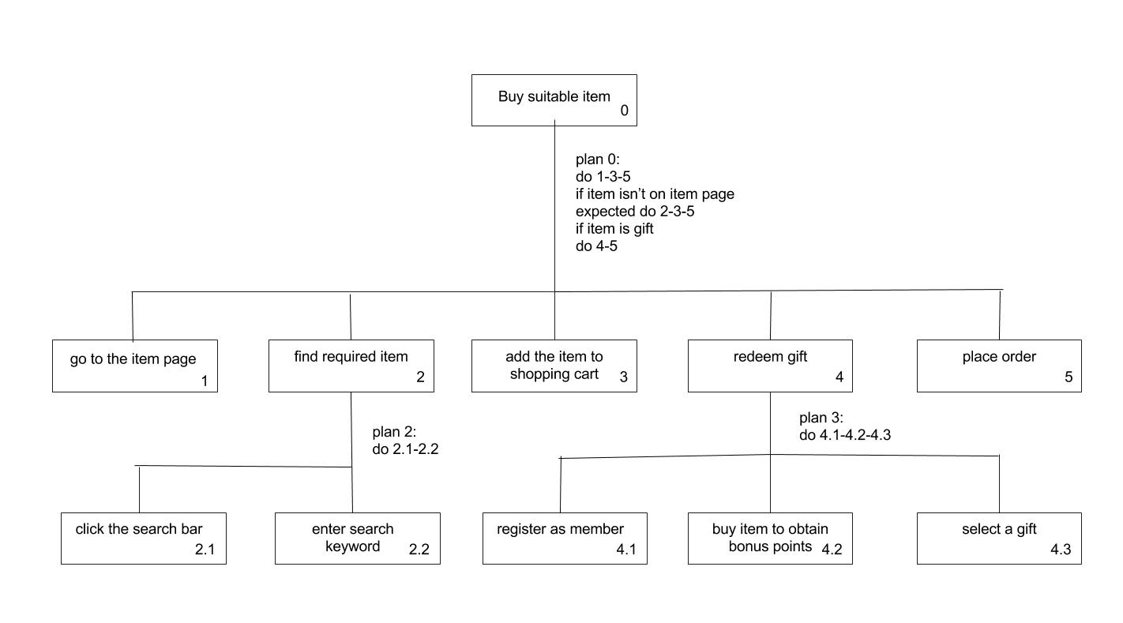

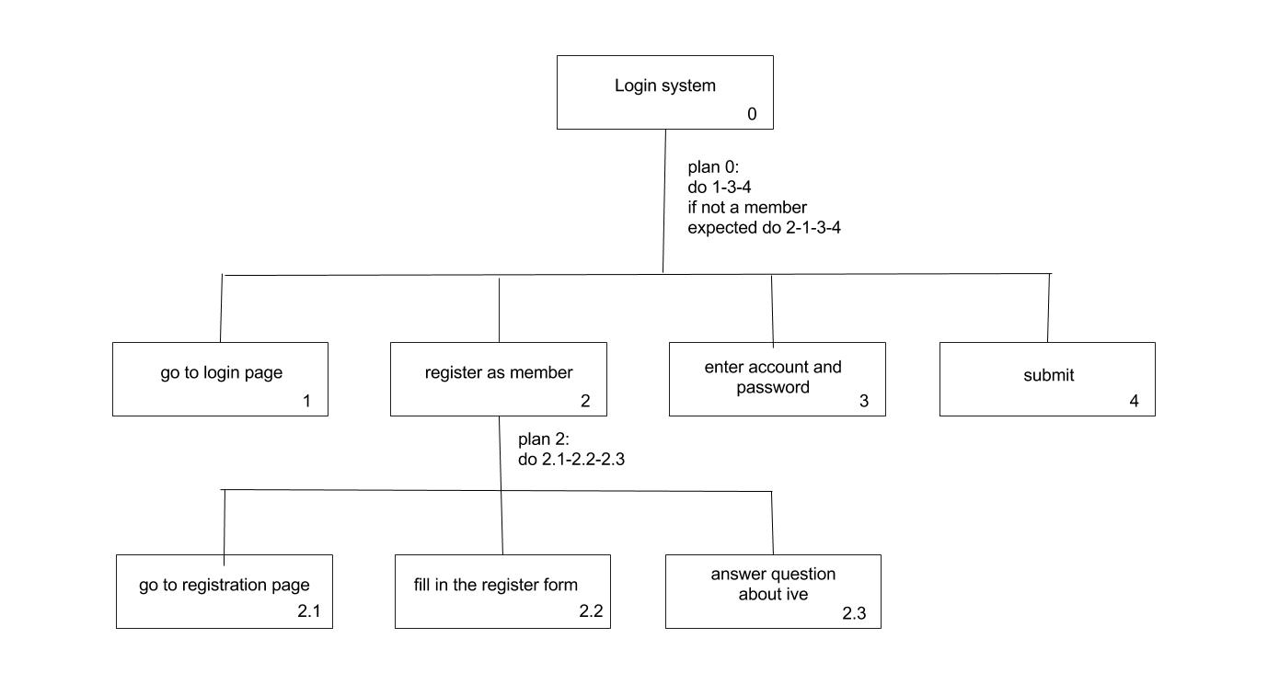

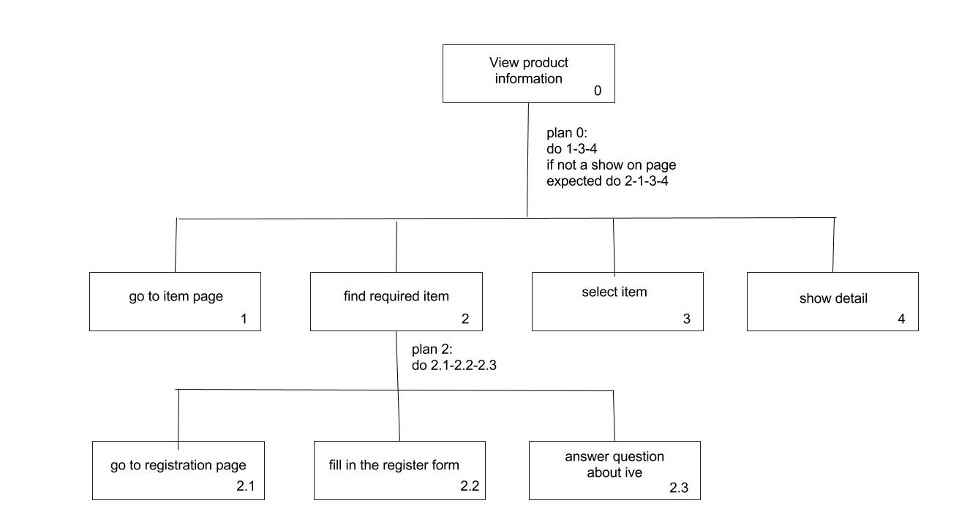

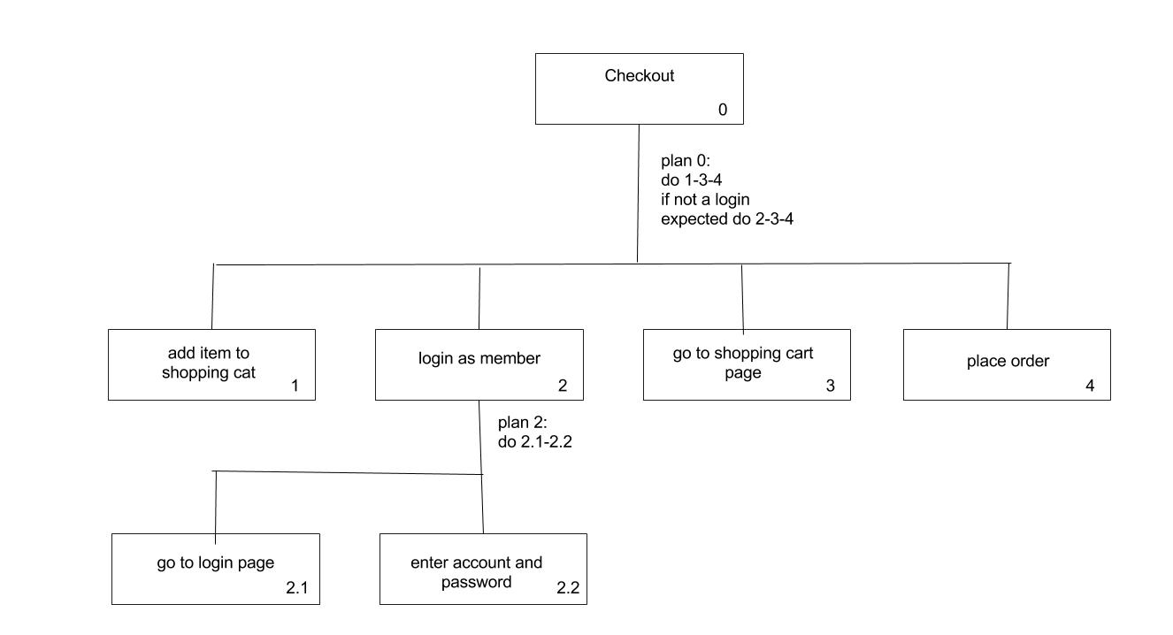

# Web Design Concepts

Mental Model

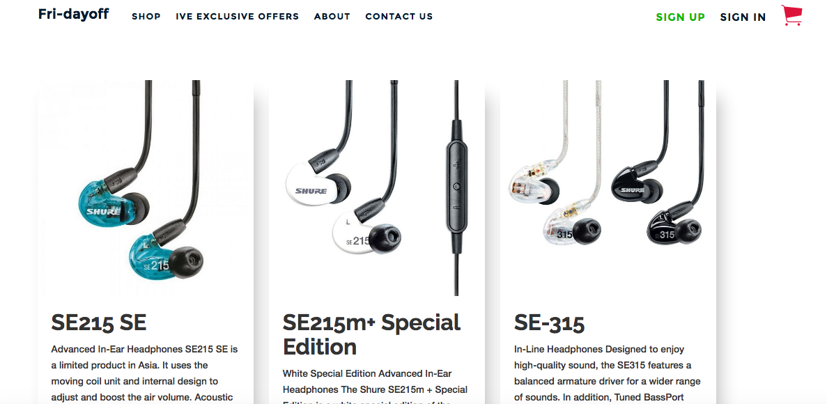

We use shopping cart icon can let user know that can show item what they buy.

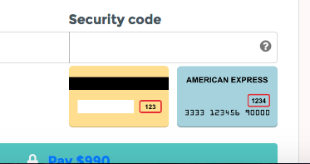

We use ? icon to let user know that’s a hints.

Affordance

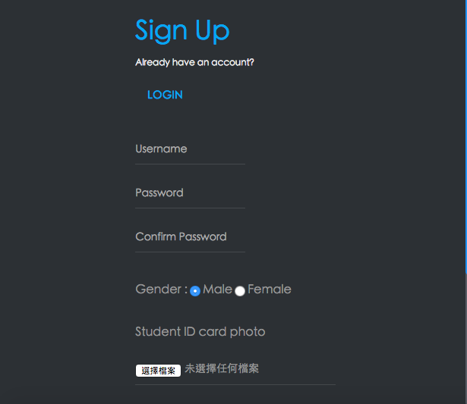

we use radio button make use know that only can choose one choice.

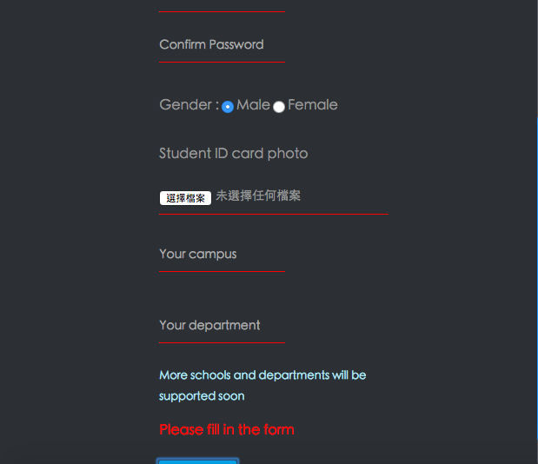

We use message to let use know how to success.

Visual Organization

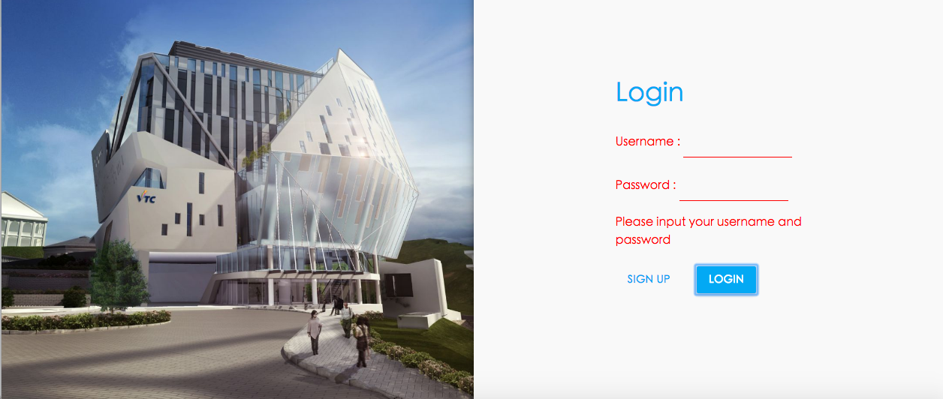

We ues ive photo to let use know which campus they are, will make they feel approachable.

Content Organization 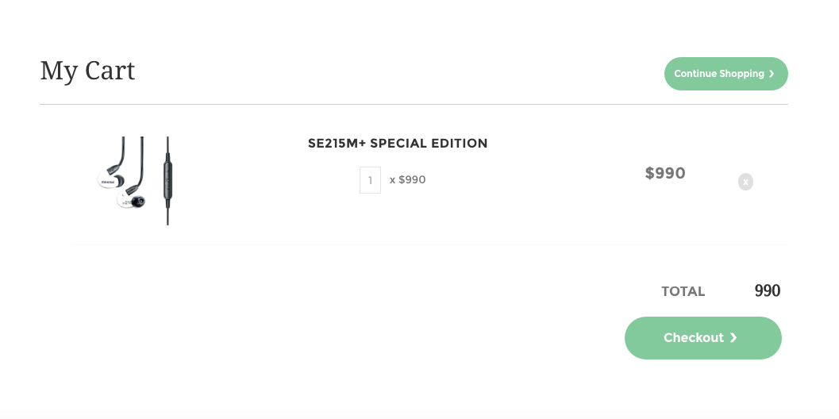

we align center.

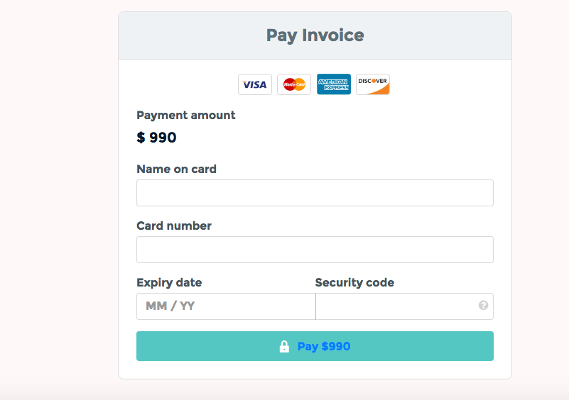

we group the payment card for page.

Navigation

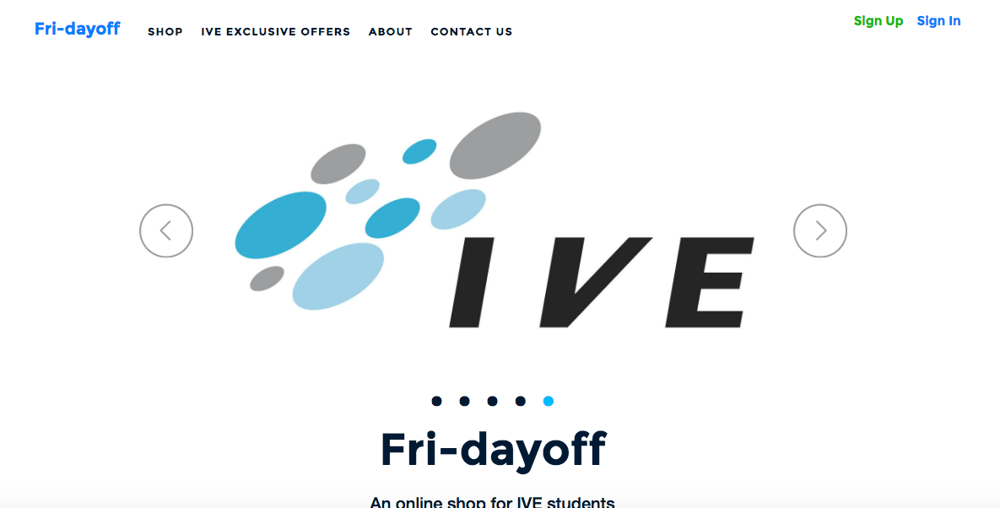

We use icon with navigation bar.